INDIGENOUS MATERIALS FOR MODERN ARCHITECTURE IN NIGERIA
Umar Abdulazeez Saidu
Department of Architectural Technology,
Federal Polytechnic Ukana, Akwa Ibom State.
Hannah Yetunde Obamoh

Department of Architectural Technology,
Federal Polytechnic Ukana, Akwa Ibom State.
Yusuf Usman
Department of Architecture,
Kaduna Polytechnic, Kaduna State.

Corresponding Author:
saidu.umar@fedpolyukana.edu.ng

ABSTRACT
Nigerian architecture continues to rely on imported, energy intensive materials such as cement, steel and glass, even though the country holds an abundant stock of indigenous resources capable of supporting durable, climate responsive buildings. Materials such as laterite, mud, bamboo and agricultural residues remain largely confined to rural or informal construction, held back by perceptions of low status, uncertain durability and the absence of a coherent professional pathway for bringing them into formal, urban practice.
A qualitative desk review approach was adopted, drawing on peer reviewed articles, systematic reviews and technical reports published from 2018 onward. Sources were grouped by material category, and findings were synthesised comparatively to establish patterns in performance, cost, adoption and constraint across earth-based, plant-based and waste-derived materials.
Earth-based products such as compressed and interlocking stabilised soil blocks carry markedly lower embodied energy and construction cost than sandcrete, while bamboo and agricultural waste pozzolans (rice husk ash, sawdust ash) offer proven, if under exploited, substitutes for imported timber and a share of cement. Adoption nonetheless, stays marginal because of weak code recognition, limited artisan training, durability scepticism among professionals and thin government incentive.
Conclusion: Indigenous materials offer a credible, largely untapped route to more affordable and environmentally sound architecture in Nigeria. Their mainstreaming depends on deliberate standardisation, demonstration projects, artisan and professional training, and supportive building-code reform, rather than on the discovery of new materials.
Keywords: Indigenous materials, Sustainable architecture, Earth construction, Bamboo, Compressed earth blocks and Nigeria.
INTRODUCTION
Buildings shape how a society experiences comfort, identity and cost of living, and the materials chosen to construct them carry consequences that outlast the projects themselves. Across much of Nigeria, the dominant image of a modern building is one clad in sandcrete, roofed with imported aluminium sheet and framed in steel or reinforced concrete. This preference has become so entrenched that it is rarely questioned, even though cement and steel are largely import dependent, energy intensive to produce, and increasingly expensive for a construction sector already burdened by a large housing deficit.
Long before these imported systems became standard, Nigerian builders worked with what their environment supplied: laterite and clay for walls, bamboo and palm timber for framing and roofing, thatch for covering, and lime or ash for binding. These materials were neither primitive nor accidental, they were tuned through generations of adjustment, to a tropical climate and to locally available resources. Recent scholarship have begun to revisit this heritage, not out of nostalgia, but because indigenous materials increasingly appear as a rational response to cost, sustainability and climate pressures the construction sector can no longer ignore (Adetoro & Gambo, 2025).
This paper examines indigenous materials as a practical resource for modern Nigerian architecture, rather than as a heritage subject alone. It asks what these materials can realistically contribute to contemporary building practice, what stands in the way of wider use, and how architects, engineers and policymakers might close that gap.
RESEARCH PROBLEM AND RESEARCH GAP
A considerable body of Nigerian researchers have examined individual indigenous materials in isolation: bamboo in one study, compressed earth blocks in another, agricultural waste ash in a third. Each strand confirms technical viability, yet three gaps persist when the literature is read as a whole. First, comparative synthesis across material categories is scarce, so an architect weighing options for a project has no single reference point showing how earth-based, plant-based and waste-derived materials compare on cost, thermal behaviour and embodied energy. Secondly, most studies stopped at technical feasibility and do not extend into the professional and regulatory obstacles that keep viable materials out of formal construction, despite evidence that scepticism among architects and weak code recognition limit adoption as much as any material property (Adetoro & Gambo, 2025). Thirdly, existing accounts of decline describe the erosion of indigenous building traditions in general terms (Ezekiel, 2021; Okafor, 2020; Nwoke, 2019) without translating that concern into a structured pathway a practising architect could follow.
This paper responds to these gaps specific evidence into one comparative framework and by proposing a staged pathway through which indigenous materials might move from marginal to mainstream use in Nigerian architecture.
OBJECTIVES
This paper is to examine indigenous materials as a resource for modern architecture in Nigeria using the following specific objectives:
- To classify the major indigenous materials available for contemporary construction.
- To compare their properties and performance against conventional alternatives.
- To identify current and emerging applications of these materials in modern building practice.
- To establish the principal barriers limiting their adoption.
- And to propose a practical pathway for integrating indigenous materials into mainstream architectural practice.
LITERATURE REVIEW
Earth remains the most studied of Nigeria's indigenous materials. Compressed and interlocking stabilised soil blocks, produced by compacting laterite with a small proportion of cement or lime, cost substantially less than sandcrete blocks while requiring little or no firing, which keeps embodied energy low (Olaleye & Ibitoye, 2023; Ibitoye et al., 2023). A systematic review confirms that waste-derived additives, such as fibres and industrial by-products, can improve the strength and durability of such blocks while addressing waste-disposal concerns at the same time (Sinha et al., 2026). Field based work outside Nigeria supported the same conclusion. Compressed earth block housing can cut operational energy use by 40 to 50 percent relative to conventional alternatives once designed for a hot climate (Hanafi, 2021).
Beyond earth, bamboo has attracted growing attention as a fast growing, low cost substitute for imported timber and steel reinforcement. Reviews of its structural and environmental properties in south eastern Nigeria confirm its suitability for scaffolding, roofing members, ceilings and, with appropriate treatment, reinforced walling (Aniegbuna & Okolie, 2021), while ecological assessments point to its rapid growth cycle and carbon sequestration potential as reasons for wider cultivation (Isukuru et al., 2023). Agricultural residues form a third, less visible category such as: rice husk, sawdust, groundnut husk and palm-kernel shell can each be converted to ash rich in reactive silica, allowing partial cement replacement in mortar and block production (Fapohunda et al., 2021), and recent characterisation of rice husk ash from Nigerian mills confirms silica content well within the range required of a usable pozzolan (Raheem & Bello, 2025).
Cultural and craft dimensions matter alongside technical performance. Documentation of traditional Igbo building finishes shows a repertoire of local plasters, pigments and decorative techniques fading from practice as imported finishing materials take over (Onuorah et al., 2022), a pattern echoed in broader accounts of indigenous architecture's decline in south eastern Nigeria (Okechukwu & Ibe, 2018; Ezekiel, 2021; Okafor, 2020; Nwoke, 2019). Overall, the technical case for indigenous materials is reasonably well established; what remains underdeveloped is the professional and regulatory pathway needed to carry that evidence into everyday practice.
METHODOLOGY
This study used a qualitative desk review design rather than laboratory testing or field survey, since its purpose is to synthesise dispersed evidence into a single comparative account. Sources were drawn from peer reviewed journal articles, systematic reviews and conference papers published from 2018 to the present, supplemented by earlier technical works only where they supplied foundational data still relied upon in current research. Materials were selected for relevance to three recurring categories: earth-based materials, plant-based materials, and waste-derived pozzolans.
Each source was read for material properties, cost implications, documented applications and reported barriers, and the extracted information was organised thematically across these categories. Numerical values in the tables and figures that follow represent indicative ranges drawn from the reviewed literature rather than measurements taken by the authors on a specific building, this suits a synthesis paper meant to orient practitioners and inform further site specific research work.
RESULTS AND DISCUSSION
Classification of Indigenous Building Materials in Nigeria
Nigeria's indigenous materials fall into three broad categories. Earth-based materials include laterite and mud used directly (cob and rammed earth) and earth compacted into blocks with a stabiliser, such as compressed stabilised earth blocks and interlocking stabilised soil blocks. Plant-based materials include bamboo, palm fronds and raffia, and various timber species used for framing, roofing and thatch. Waste-derived pozzolans are ash products obtained by burning agricultural residues, including rice husk, sawdust, groundnut husk and palm-kernel shell, which supply reactive silica for partial cement replacement. Figure 1 sets out this classification.
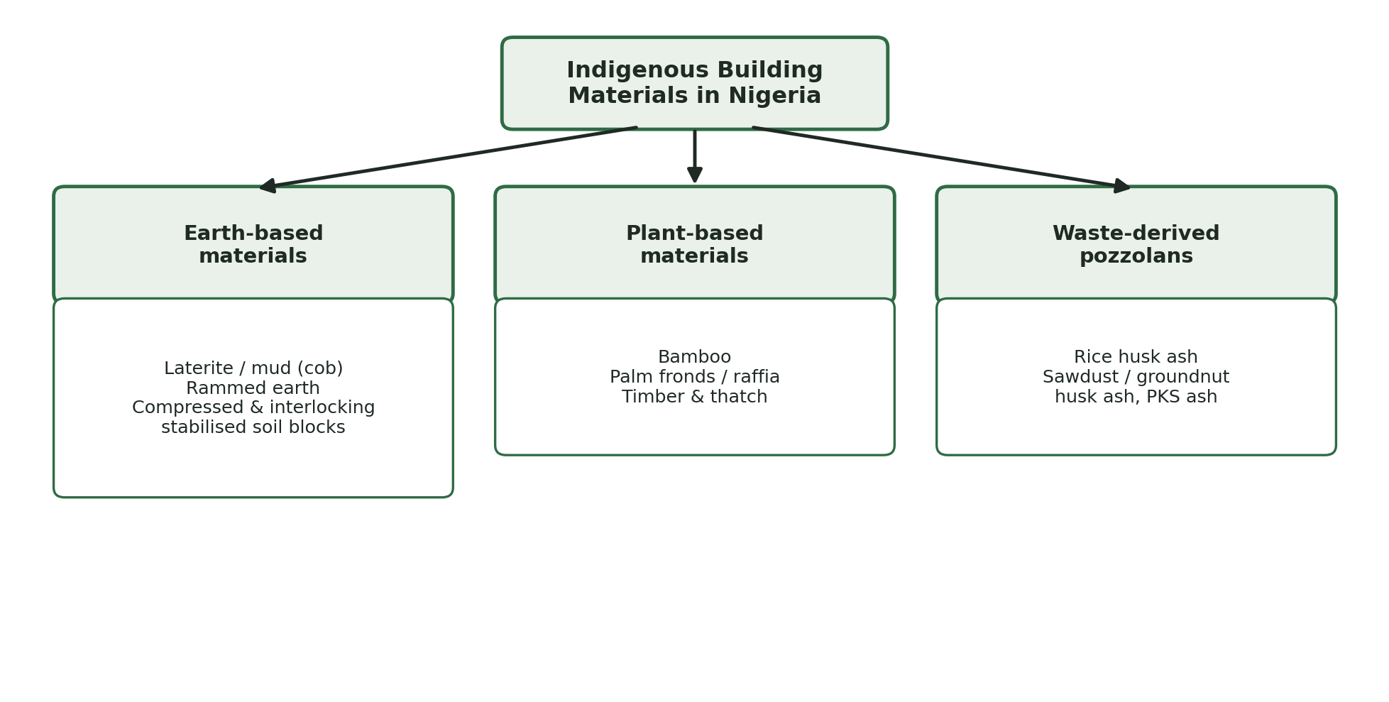
Figure 1: Classification of major indigenous building materials in Nigeria. Source: Authors' synthesis from reviewed literature.
Table 1: Major indigenous material categories, examples and typical applications.
Category | Examples | Typical application
Earth-based materials | Laterite/mud (cob), rammed earth, compressed stabilised earth blocks, interlocking stabilised soil blocks | Load-bearing walls, partitioning, low-cost housing
Plant-based materials | Bamboo, palm fronds/raffia, timber, thatch | Roofing, scaffolding, ceilings, screens, reinforcement
Waste-derived pozzolans | Rice husk ash, sawdust ash, groundnut husk ash, palm-kernel shell ash | Partial cement replacement in mortar and blocks

Comparative Properties and Performance
The evidence reviewed points consistently to lower embodied energy and cost for earth-based walling than for sandcrete or fired clay brick, since blocks are air cured or lightly stabilised rather than fired, and the raw material is sourced on or near the site (Olaleye & Ibitoye, 2023; Sinha et al., 2026). Figure 2 presents an indicative comparison, expressed as an index against sandcrete block as the conventional baseline.
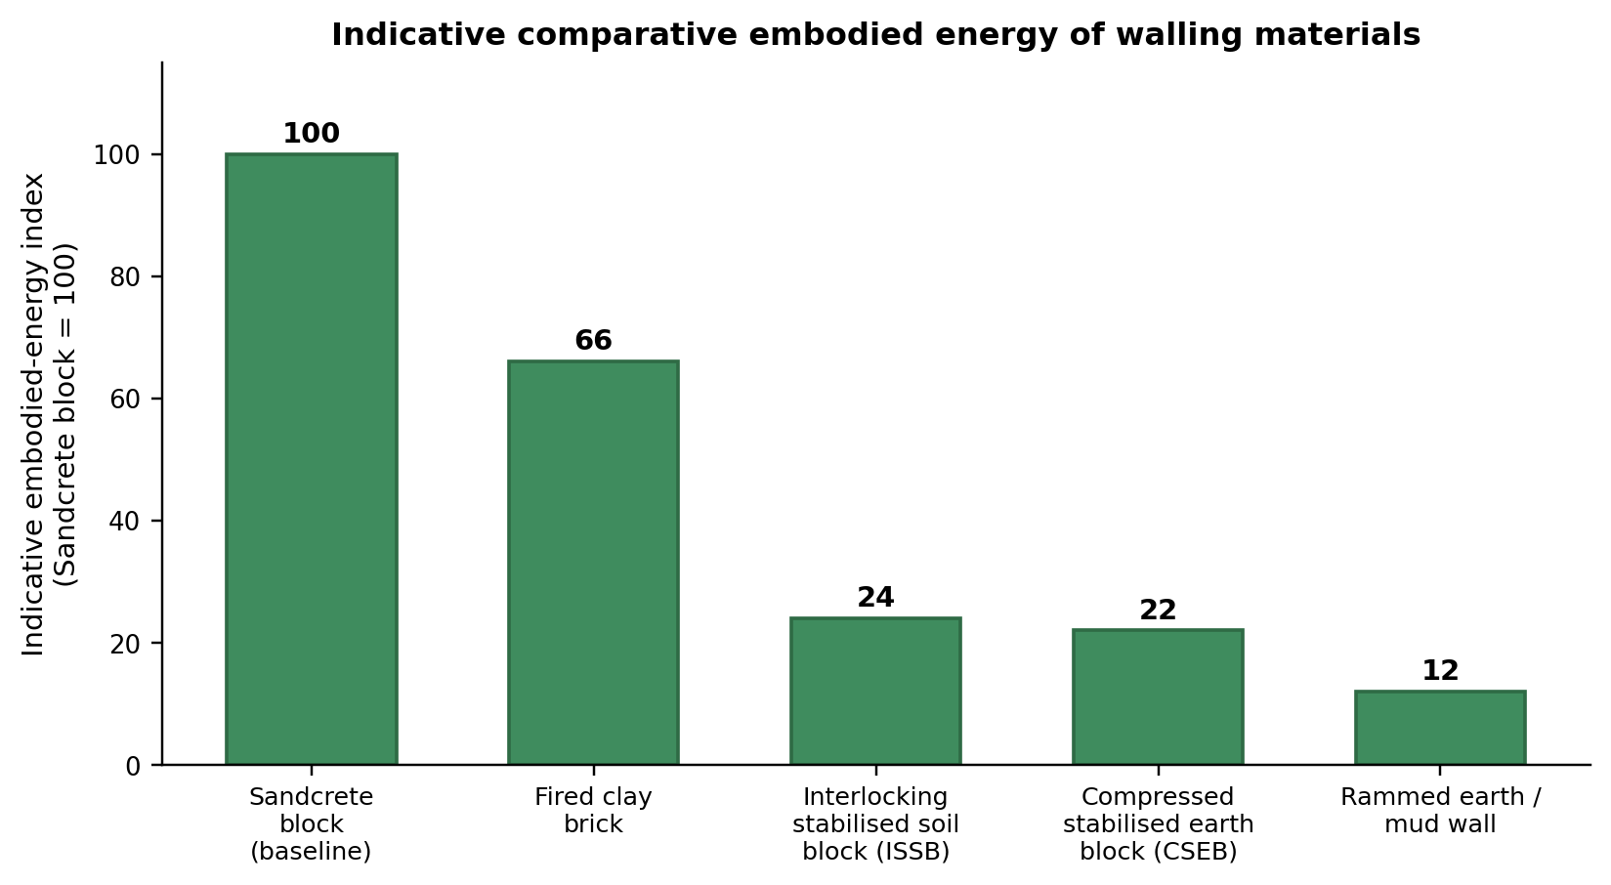
Figure 2: Indicative comparative embodied energy of walling materials. Source: Authors' synthesis from reviewed literature.
Table 2: Comparative indicative properties of selected indigenous and conventional materials.
Material | Embodied energy | Relative cost | Thermal performance | Local availability
Sandcrete block | High (baseline) | High | Moderate | High
Interlocking stabilised soil block | Low | Low | Good | High
Compressed stabilised earth block | Low | Low-medium | Good | Medium-high
Bamboo | Very low | Low | Good (roofing/shading) | Medium
Ash-blended cement (RHA/SDA) | Low-medium | Low | Not applicable | Medium

Contemporary Applications and Integration in Modern Practice
Indigenous materials are already finding their way into formal construction, usually through pilot or niche projects rather than mainstream practice. Interlocking stabilised soil blocks have been used in estate scale housing in south western Nigeria, where cost comparisons continue to favour them over sandcrete (Ibitoye et al., 2023). Architects on Lagos Island have begun re-engaging with mud construction on a project basis, motivated by its ecological and cultural value even where regulatory support remains uneven (Adetoro & Gambo, 2025). Bamboo already appears in scaffolding and informal roofing and is increasingly proposed for ceilings, screens and reinforced panels as treatment methods improve (Aniegbuna & Okolie, 2021). Agricultural waste ash is used mainly at block production scale, blended into cement for sandcrete or interlocking blocks (Fapohunda et al., 2021; Raheem & Bello, 2025). Table 3 summarises these applications.
Table 3: Contemporary applications of indigenous materials in Nigerian construction.
Material | Application observed | Illustrative context
Interlocking stabilised soil block | Estate-scale affordable housing | South-western Nigeria housing estates (Ibitoye et al., 2023)
Mud/rammed earth | Project-based professional re-engagement with mud walling | Architectural practice on Lagos Island (Adetoro & Gambo, 2025)
Bamboo | Scaffolding, roofing members, ceilings, emerging reinforced panels | South-eastern Nigeria construction sites (Aniegbuna & Okolie, 2021)
Agricultural-waste ash | Partial cement replacement in block and mortar production | Sandcrete and interlocking block manufacture (Fapohunda et al., 2021)

Barriers to Mainstream Adoption
Despite favourable cost and environmental performance, indigenous materials face barriers that are more professional and institutional than technical. Architects frequently doubt the durability of earth-based construction, a scepticism that persists even where improved stabilisation techniques address the underlying concern (Adetoro & Gambo, 2025). Formal building codes rarely give indigenous materials the same standing as cement based systems, discouraging specification on regulated projects, while skilled artisanship in traditional finishing is thinning, as documented among Igbo builders whose plastering practices are being displaced by imported alternatives (Onuorah et al., 2022). Table 4 sets out these barriers alongside possible responses.
Table 4: Barriers to the mainstream adoption of indigenous materials and proposed responses.
Barrier | How it limits adoption | Recommended response
Durability scepticism | Architects and clients doubt long-term performance of earth and plant-based walling | Demonstration buildings, published performance data, updated professional training
Weak code recognition | Building regulations rarely specify or test indigenous materials | Develop national testing standards for stabilised earth and bamboo systems
Declining artisan skills | Traditional finishing and construction techniques are disappearing | Apprenticeship schemes and curriculum inclusion in built-environment programmes
Limited production scale | Ash-based pozzolans and treated bamboo remain small-scale or informal | Grants and incentives for block-manufacturing and treatment enterprises
Cultural perception | Indigenous materials are associated with poverty rather than sustainability | Awareness campaigns reframing indigenous materials as modern and eco-conscious

A Pathway for Mainstreaming Indigenous Materials
Moving indigenous materials from the margins to the mainstream of Nigerian architecture is unlikely to happen through isolated projects alone; it requires a deliberate sequence of steps that connects research, regulation and the market. Figure 3 proposes such a pathway, beginning with documentation and material characterisation and ending with mainstream adoption once codes, training and demand have caught up with the underlying technical evidence.
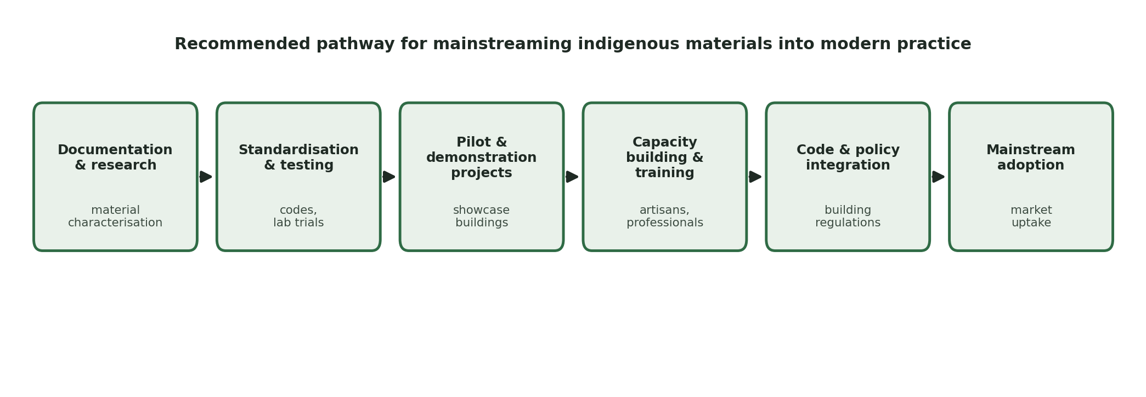
Figure 3: Recommended pathway for mainstreaming indigenous materials into modern Nigerian architecture. Source: Authors' synthesis, 2026.
POLICY AND PROFESSIONAL IMPLICATIONS
Architects and engineers have a direct role to play by specifying indigenous materials where site conditions and client goals allow, rather than treating them as a fallback for low budget projects only. Doing so credibly requires professionals to update their understanding of current stabilisation and treatment techniques, since much of the scepticism documented in the literature rests on outdated impressions of durability (Adetoro & Gambo, 2025). Educational institutions and professional bodies can support this shift by embedding indigenous material design and testing into curricula, addressing the skills gap identified around traditional finishing (Onuorah et al., 2022).
At policy level, agencies responsible for building regulation should extend formal recognition to properly stabilised earth blocks, treated bamboo systems and ash-blended cement products, supported by testing standards that give specifiers and inspectors a basis for approval. Public demonstration buildings, procured directly by government or supported through targeted grants, would give the sector visible, occupied examples that address the durability concerns limiting private-sector uptake.

CONCLUSION
This paper examined indigenous materials as a resource for modern architecture in Nigeria, drawing together recent evidence on earth-based, plant-based and waste-derived materials. The review shows that these materials already perform competitively on cost and embodied energy relative to conventional alternatives, and that pilot applications exist across housing, institutional and informal construction. What limits their wider use is not primarily technical: it is the combination of professional scepticism, thin code recognition, and a shrinking base of skilled traditional artisanship.
Bringing indigenous materials into mainstream Nigerian architecture therefore depends less on further material discovery than on deliberate, staged action: standardisation and testing, demonstration projects, training for artisans and professionals, and supportive building-code reform. Future research should test these indicative comparisons against measured data from occupied buildings across Nigeria's varied climatic zones, to build the locally grounded evidence base that policy and practice both require.
RECOMMENDATIONS
1. Professional bodies should update continuing education content to reflect current stabilisation, treatment and testing techniques for indigenous materials, correcting outdated durability perceptions among practising architects and engineers.
2. Government building regulation agencies should develop or adopt testing standards that give compressed and interlocking stabilised soil blocks, treated bamboo systems and ash-blended cement products formal standing in the national building code.
3. State and local governments should commission demonstration buildings using indigenous materials in public facilities, providing visible, occupied reference projects for private-sector clients.
4. Polytechnics and universities should include hands-on training in indigenous-material production and traditional finishing techniques within architecture, building and civil engineering curricula.
5. Block-manufacturing and cement-blending enterprises should be supported, through grants or tax incentives, to scale up production of agricultural-waste pozzolans such as rice husk and sawdust ash.
6. Future research should measure the in-service thermal, structural and durability performance of indigenous-material buildings across Nigeria's climatic zones to validate the indicative ranges presented in this paper.

REFERENCES
Adetoro, O. C., & Gambo, E. B. (2025). Sustainable futures in indigenous architecture: A study of contemporary professional engagement with mud techniques in Nigeria. Frontiers in Built Environment, 11, 1674149.
Aniegbuna, A. I., & Okolie, K. C. (2021). Exploring the potentials in bamboo as a sustainable building material for construction in South East Nigeria. Environmental Review, 8(2), 73-84.
Ezekiel, R. (2021). Modernization and the decline of indigenous architecture in South-Eastern Nigeria: Cultural and environmental implications. Heritage and Sustainability Press.
Fapohunda, C., Kilani, A., Adigo, B., Ajayi, L., Famodimu, B., Oladipupo, O., & Jeje, A. (2021). A review of some agricultural wastes in Nigeria for sustainability in the production of structural concrete. Nigerian Journal of Technological Development, 18(2), 76-87.
Hanafi, W. H. (2021). Compressed stabilized earth block: Environmentally sustainable alternative for villages housing. Journal of Engineering and Applied Science, 68(1), 1-13.
Ibitoye, O. A., Abiola, O. A., & Babamboni, A. S. (2023). Demographic characteristics of housing estates developed with ISSB technology in selected Southwestern Nigerian cities. FUDMA Journal of Sciences, 7(2), 275-283.
Isukuru, E. J., Ogunkeyede, A. O., Adebayo, A. A., & Uruejoma, M. F. (2023). Potentials of bamboo and its ecological benefits in Nigeria. Advances in Bamboo Science, 4, 100032.
Nwoke, P. (2019). The evolution of indigenous architecture in South-Eastern Nigeria: Impacts on modern construction practices. Eco-Architecture Publishing.
Okafor, J. (2020). Sustaining indigenous architecture: Challenges and opportunities in South-Eastern Nigeria. Eco-Design Publications.
Okechukwu, T., & Ibe, K. (2018). The impact of imported materials on sustainable construction in Nigeria: Challenges and alternatives. Green Architecture Press.
Olaleye, A. A., & Ibitoye, O. A. (2023). Architects' response on utilisation of interlocking stabilised soil blocks as an alternative building material for housing projects in Southwest Nigeria. FUDMA Journal of Sciences, 6(5), 198-202.
Onuorah, I. M., Agbonome, P. C., & Obiadi, B. N. (2022). A comparative study of Igbo traditional building finishings. International Journal of Research and Scientific Innovation, 9(12), 99-107.
Raheem, A. A., & Bello, T. (2025). Characterization of rice husk ash obtained from five rice producing companies in Nigeria. Materials Research Proceedings.
Sinha, S., Sudarsan, J. S., & Abhyankar, A. A. (2026). Compressed stabilized earth blocks for sustainable building construction: A PRISMA-guided systematic review and TCCM analysis. Buildings, 16(8), 1633.

